Drum Major Individual Entry Form

24th Annual
Glasgow Lands Scottish Festival

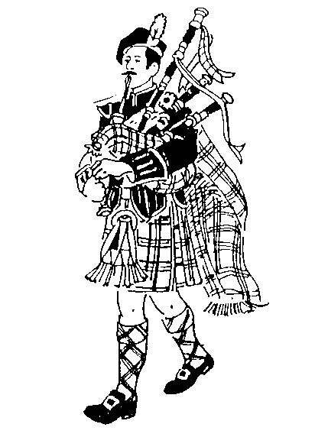

Drum Major Competition
Sanctioned by EUSPBA

Saturday July 15, 2017
Rain or Shine
Look Park
300 North Main Street

Florence, Massachusetts

Solo Events Scheduled to Start 8:00 AM

Massed Bands at 11:30 AM & 5:30 PM

Pipe Band Competitions to Start 1:00 PM

Drum Major Competition after Opening Ceremonies – approximately 12:15

www.glasgowlands.org

The location of the contest will be announced after 8am at Registration.

A duty band will be provided by the Festival.

The prizes will be as follows:

Amateur: Medals
Professional: $100 first place
$75 second place
$50 third place

ENTRY FEES:
Professional $25.00
Amateur $15.00
(Circle which applies)

Additional Tickets:
Adults: __________x $13 _________
Children (Age 6-12): _________x $ 5 _________

Total: _____________

QUESTIONS?
Contact: Janet at 413-267-9197
or at
foy18@comcast.net
Please enter me in the events listed. I hereby, for myself, my heirs, executor and administrators, waive and release any and all claims I may have for damages against Glasgow Lands Scottish Festival, Inc., their agents or representatives and the owner of the property on which the Games are held, for any injuries which may be suffered by me during the Glasgow Lands Scottish Festival.

Signature (of parent or guardian, if under 18 years of age)

Please print legibly

Name: ____________________________________

Address: ____________________________________

____________________________________

City: ____________________________________

State: _________________ Zip:____________

Telephone #_________________________________

Email: ____________________________________

EUSPBA #: ________________________________

Grade (Professional vs Amateur): _______________

Event: Drum Major Competition____________

Check Number: __________________________

All entries MUST be postmarked, no later than June 24th!

In order to receive your ticket, the required entry fee, entry form, and a Self-Addressed Stamped Envelope must be mailed to:
Glasgow Lands Scottish Festival, Inc.
Janet Foy
18 Palmer Rd Unit 15
Monson, MA 01057

Please make all checks payable to:

GLASGOW LANDS SCOTTISH FESTIVAL, INC.

