Solo Piping Entry Form

24th Annual
Glasgow Lands Scottish Festival

Saturday,
July 15, 2017
Rain or Shine
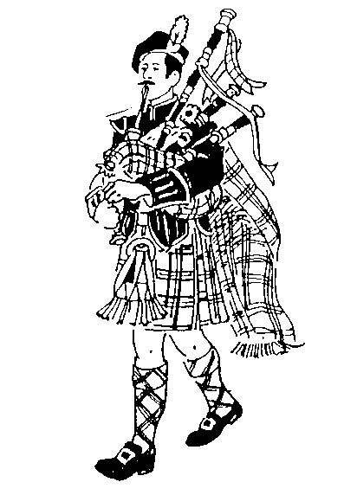

Piping & Drumming
Competitions
Sanctioned by the EUSPBA
Look Park
300 North Main Street

Florence, Massachusetts

Solo Events Scheduled to Start 8:00 AM

Massed Bands at 11:30 AM & 5:30 PM

Pipe Band Competitions to Start 1:00 PM

www.glasgowlands.org

Please enter me in the events listed. I hereby, for myself, my heirs, executor and administrators, waive and release any and all claims I may have for damages against Glasgow Lands Scottish Festival, Inc., their agents or representatives and the owner of the property on which the Games are held, for any injuries which may be suffered by me during the Glasgow Lands Scottish Festival.

Signature (of parent or guardian, if under 18 years of age)

AMATEUR PIPING
All solos to follow EUSPBA rules.

GRADE 1
- Piobaireachd Submit 3 selections
- MSR
- Hornpipe/Jig

GRADE 2
- Piobaireachd Submit 2 selections
- Strathspey & Reel
- 2/4 March

GRADE 3
- Piobaireachd Submit 1 selection
- Strathspey & Reel
- 2/4 March

Grade 4 SR
- Piobaireachd Submit 1 selection
- Strathspey & Reel
- 2/4 March

GRADE 4 JR
- Piobaireachd: Submit 1 selection
- Strathspey & Reel
- 2/4 March

GRADE 5 PRACTICE CHANTER *
- 4 Part March

All marches submit one 4-part selection.

*Note: Entry single entry fee is $40.
Fee for Practice Chanter only $15.

Please circle the events you wish to enter.

Questions?
Contact: Janet at 413-267-9197 foy18@comcast.net

*INDIVIDUAL EVENT FEES*

Single Entry Fee ………….…… $ 40.00____
(Change to $15 if Chanter)

Additional Tickets:
Adults: __________x $13 _________
Children (Age 6-12): _________x $ 5 _________
Total: _________

Please print legibly

Name: ________________________________________

Address: ________________________________________

________________________________________

City: ___________________State: ______Zip :______

DOB (Grade 4 Jr only): ____________________________

Telephone #: _____________________________________

Email: ________________________________________

EUSPBA #: _____________________________________

Events #(s): _____________________________________

Check Number: ____________________________

All entries MUST be postmarked, no later than June 24th!

In order to receive your ticket, the required entry fee, entry form, and a Self-Addressed Stamped Envelope must be mailed to:
Glasgow Lands Scottish Festival, Inc.
Janet Foy
18 Palmer Rd Unit 15
Monson, MA 01057

Please make all checks payable to:

GLASGOW LANDS SCOTTISH FESTIVAL, INC.

